Warcraft III: Reign of Chaos, is a high fantasy real-time strategy computer game developed and published by Blizzard Entertainment. It was released in July 2002 as the sequel to Warcraft II: Beyond the Dark Portal and the third game in the Warcraft series. The game centers around four playable races: the Orcs, Humans, Night Elves, and the Undead Scourge.

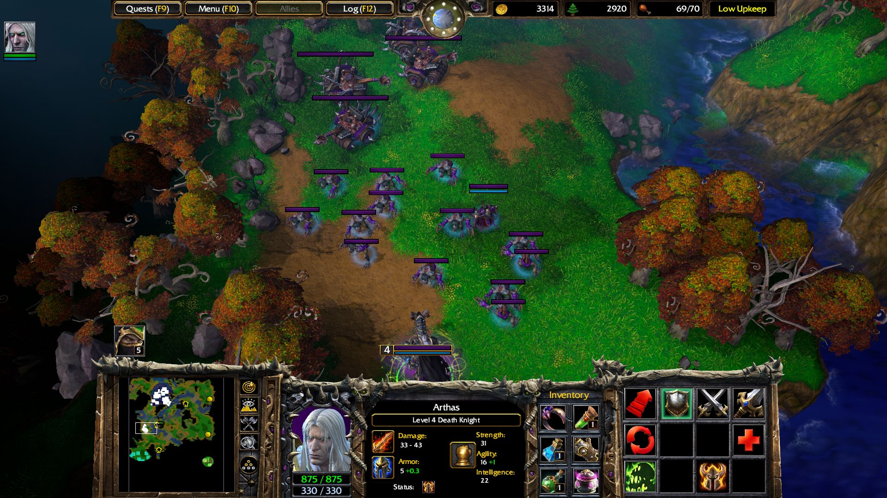

Warcraft III features a single-player campaign that follows the story of each race and their struggle against the Burning Legion, a demonic army that threatens to consume the world of Azeroth. The game also includes a robust multiplayer mode that allows players to compete against each other online.

Warcraft III was a critical and commercial success, selling over 4.5 million copies by 2004. It is considered one of the greatest real-time strategy games of all time and has been praised for its immersive story, engaging gameplay, and innovative features.

In 2003, an expansion pack titled Warcraft III: The Frozen Throne was released, which added a new campaign, new hero units, and a new neutral race. The Frozen Throne was also a critical and commercial success, and it is often considered to be an essential part of the Warcraft III experience.

In 2019, a remastered version of Warcraft III, titled Warcraft III: Reforged, was announced. Reforged features updated graphics, sound, and user interface. It was released in January 2020.